**Jenkins Lab3**

**Name: Mohamed Mostafa Mostafa Esmael Track: System Administration Branch: Aswan**

## 1-what is the benefit of using master-slave architecture rather than building on master only ?

* **Resource Isolation:**  
  Offloading builds to agent nodes prevents the master from being overloaded. This keeps the master responsive and available for administrative tasks.
* **Scalability:**  
  You can add as many agents as needed, allowing builds to run concurrently. This improves overall throughput and shortens build times.
* **Environment Specialization:**  
  Agents can be tailored with specific software, OS versions, or hardware configurations required by different projects. This helps test across multiple environments without affecting the master.
* **Security & Stability:**  
  Isolating build environments minimizes the risk of a faulty build affecting the master. It also helps contain security issues by limiting the exposure of the master node.
* **Maintenance Flexibility:**  
  Agents can be updated, restarted, or replaced independently from the master. This improves maintenance without impacting the entire CI/CD pipeline.

## 2-try to make new agent as container using docker plugin and configure master to use it and build pipeline on this agent

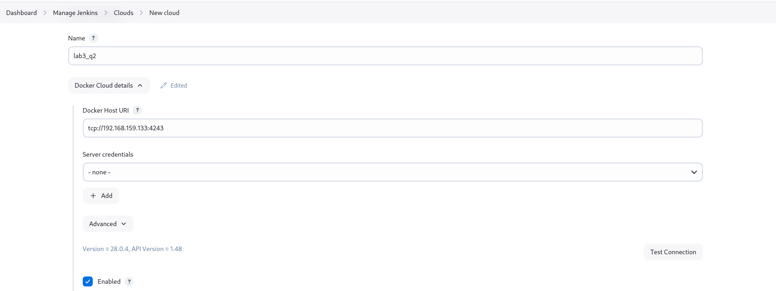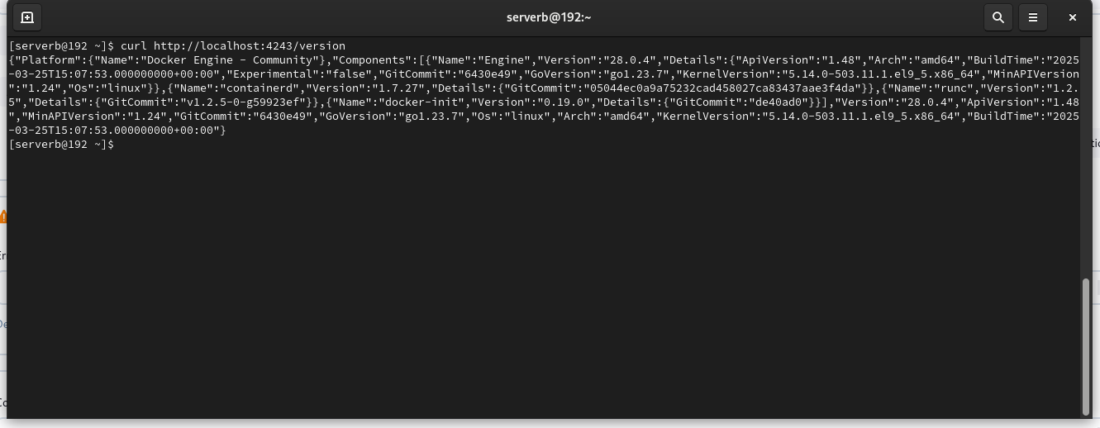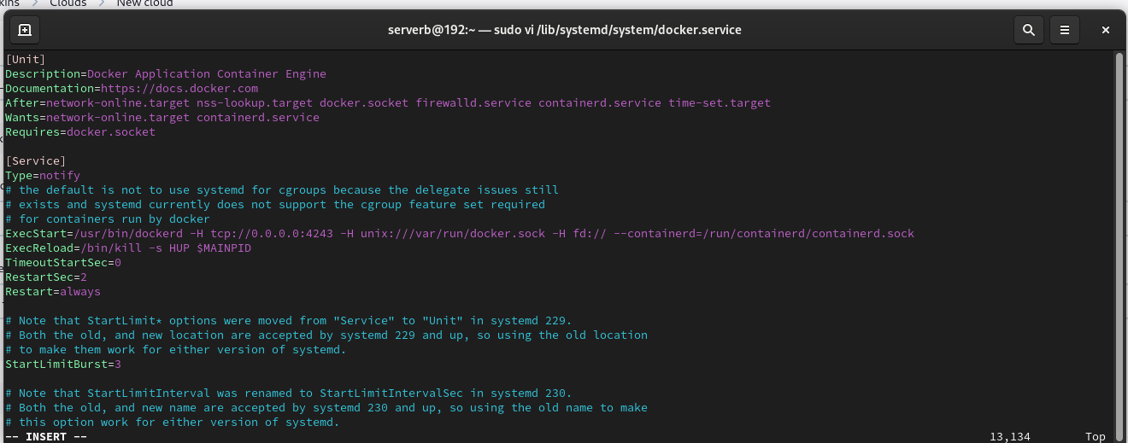

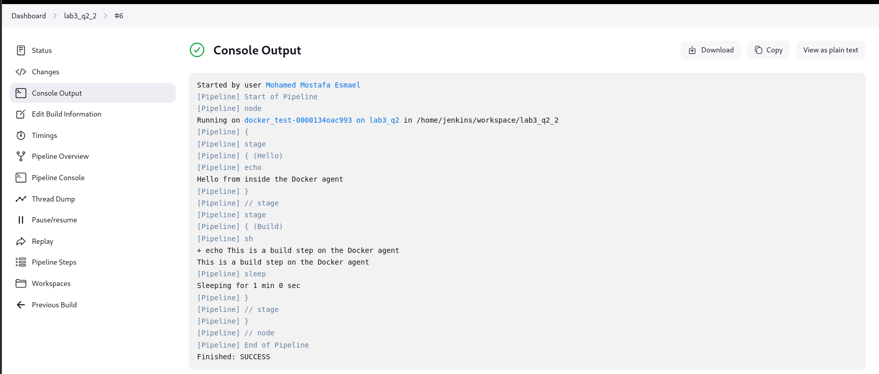

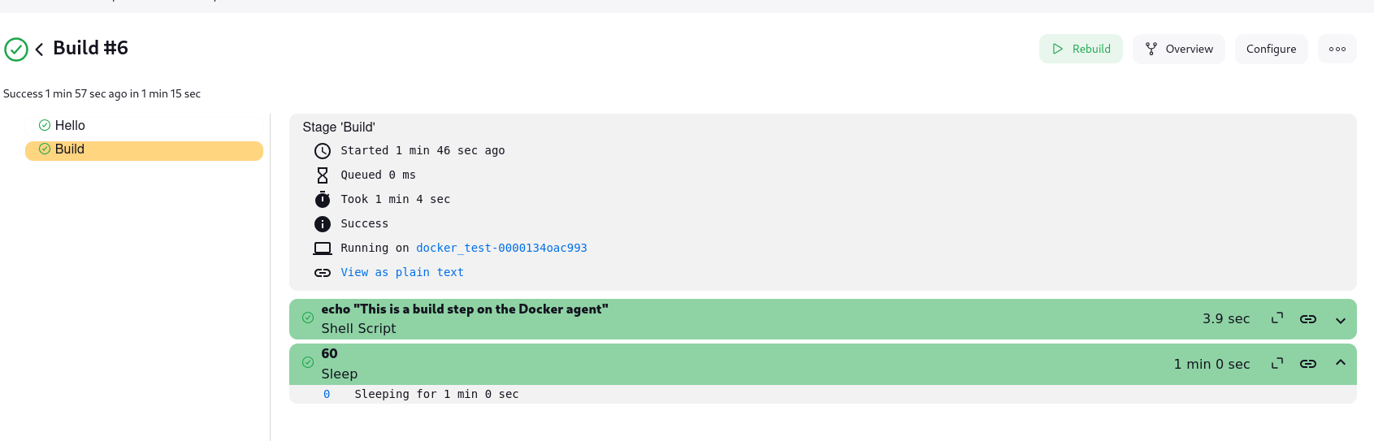

## 3-run pipeline to run bash script located on github repo

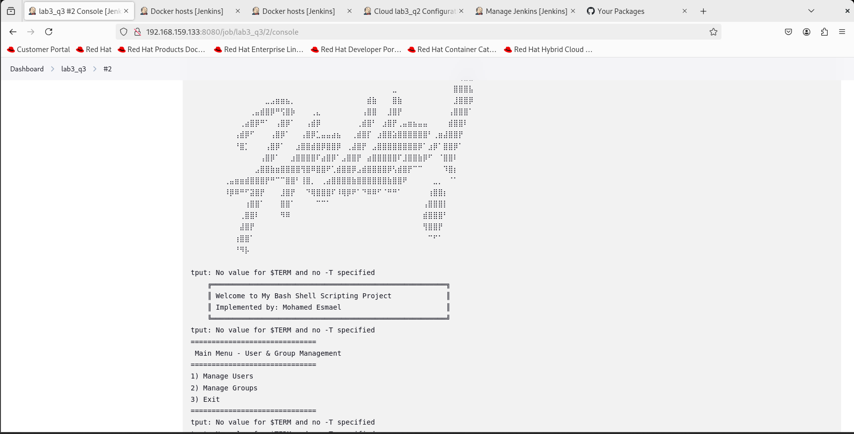

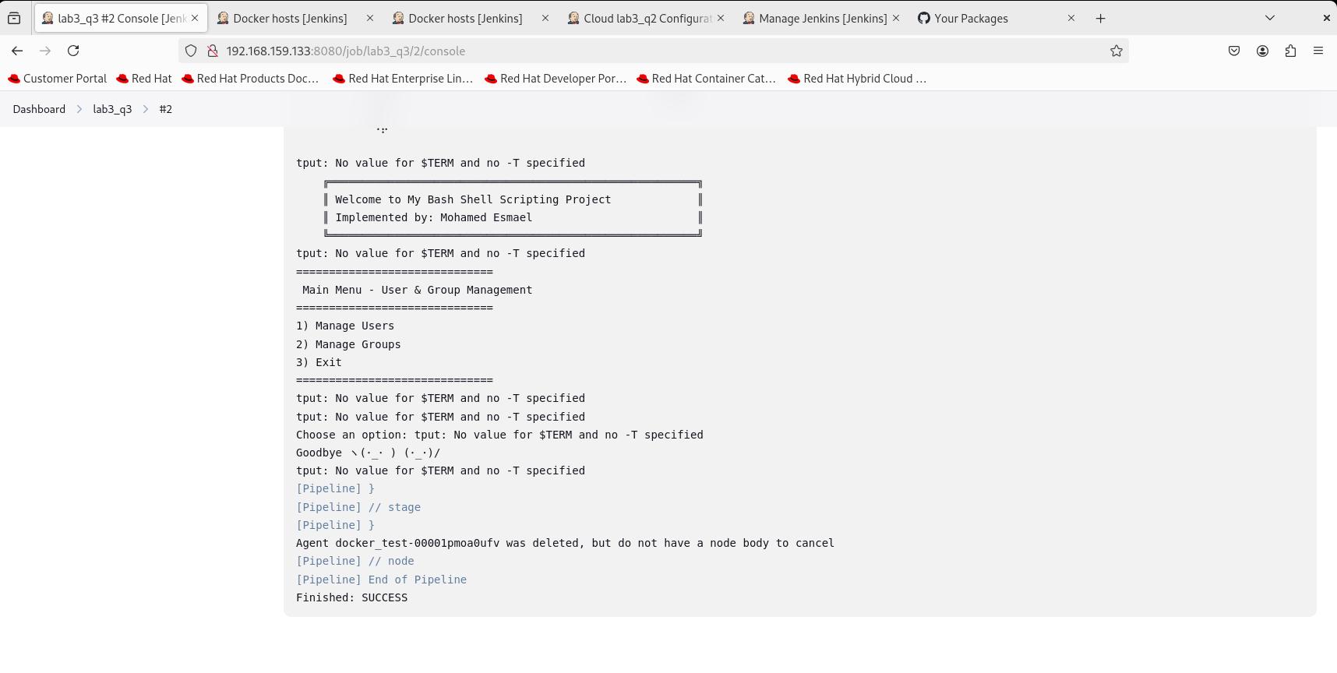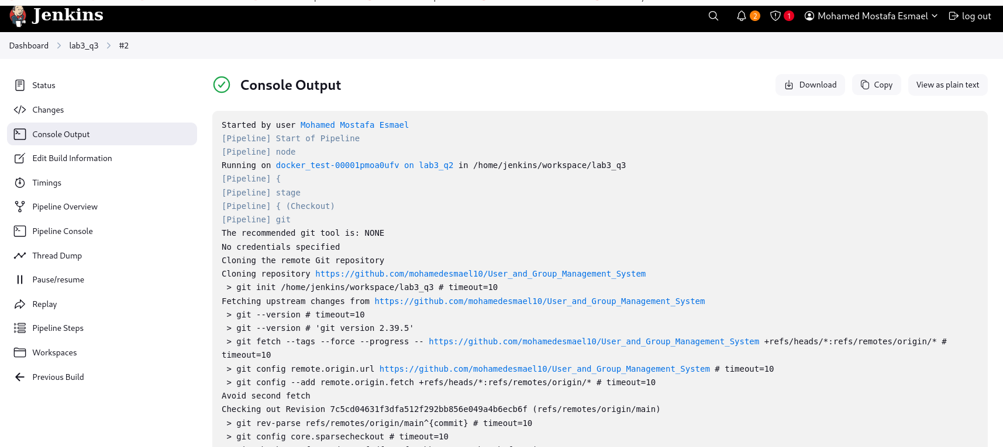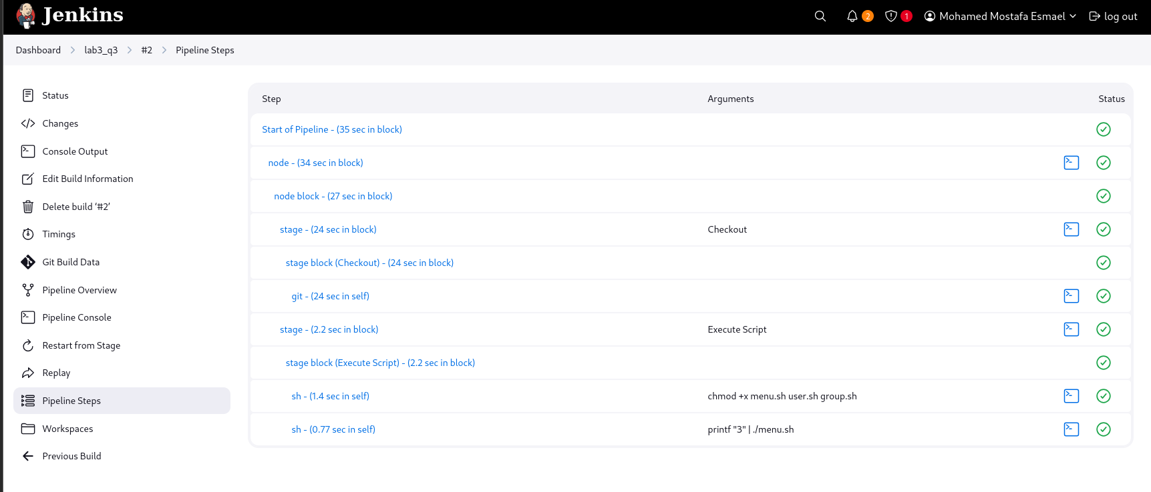

## 4-run new pipeline using jenkins shared library to build, push dockerfile existed on github repo

## GITHUB Repo: <https://github.com/mohamedesmael10/jenkins-shared-library>

